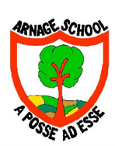
All about me

My name is
_________________________

This is a picture of me in my school uniform
(We’ll do this bit in class in August)
The people who live in my house are… | My other close family members and what I call them… | Some of my friends are…
I like… | I dislike… | Is there anything that can worry/unsettle you?
What are the things that make you feel comforted/safe/secure? | My favourite foods are… | Foods I dislike are…
I like to play… | My favourite stories are… | Things I’m looking forward to about starting school…
The things I think are really important for the adults at my school to know… | My allergies… | The people who might collect me from school are…
Getting to know you

Please complete the information below with your child at home and return it to school

